SET 3 *CONFERENCE MANAGEMENT*

*Usecase diagram:*

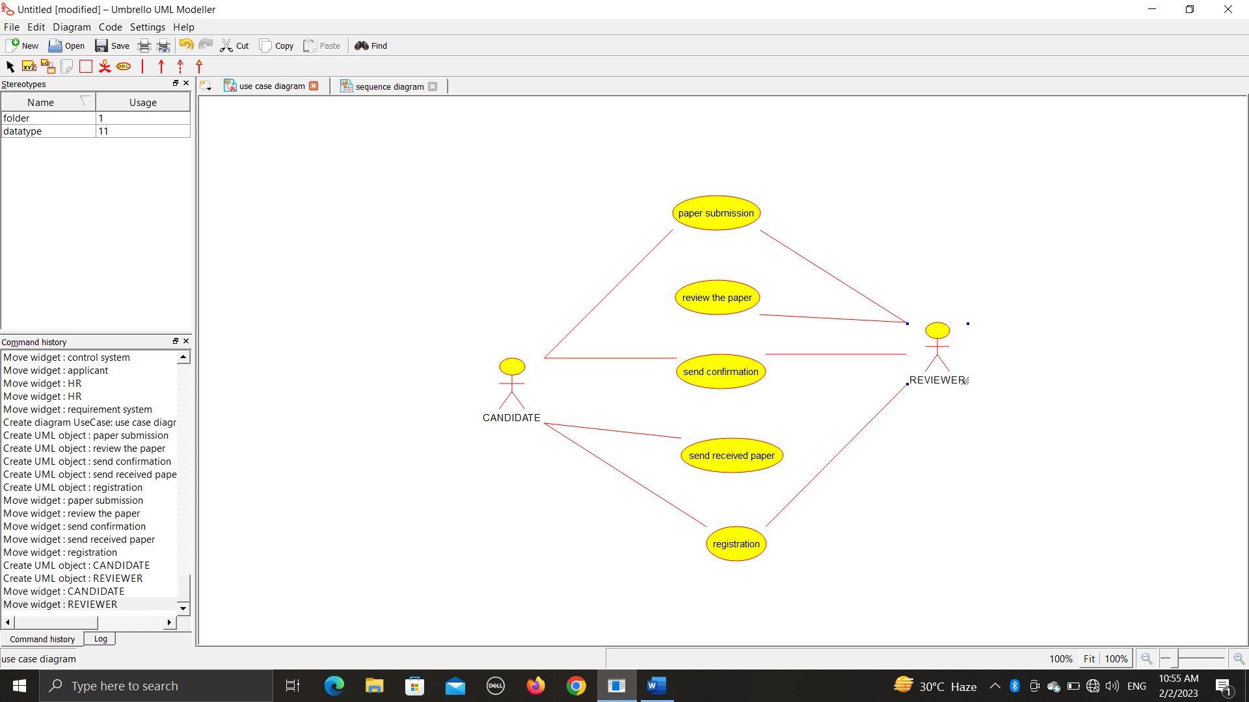

*Class diagram:*

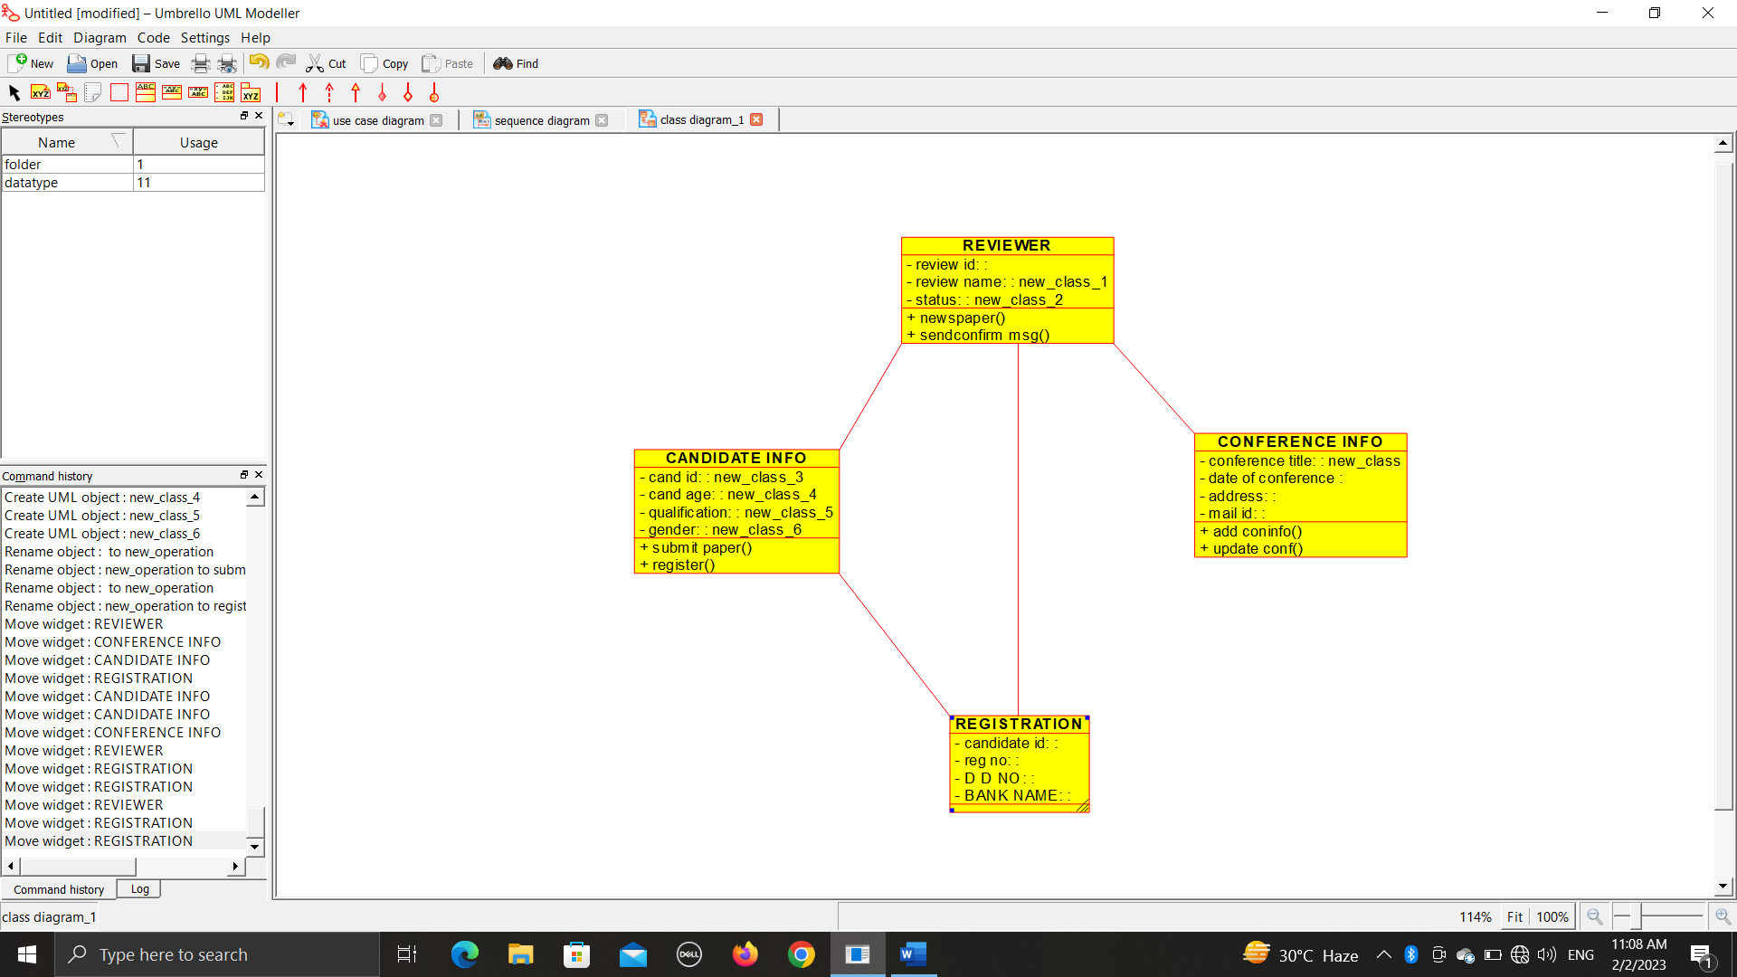

*Sequence diagram:*

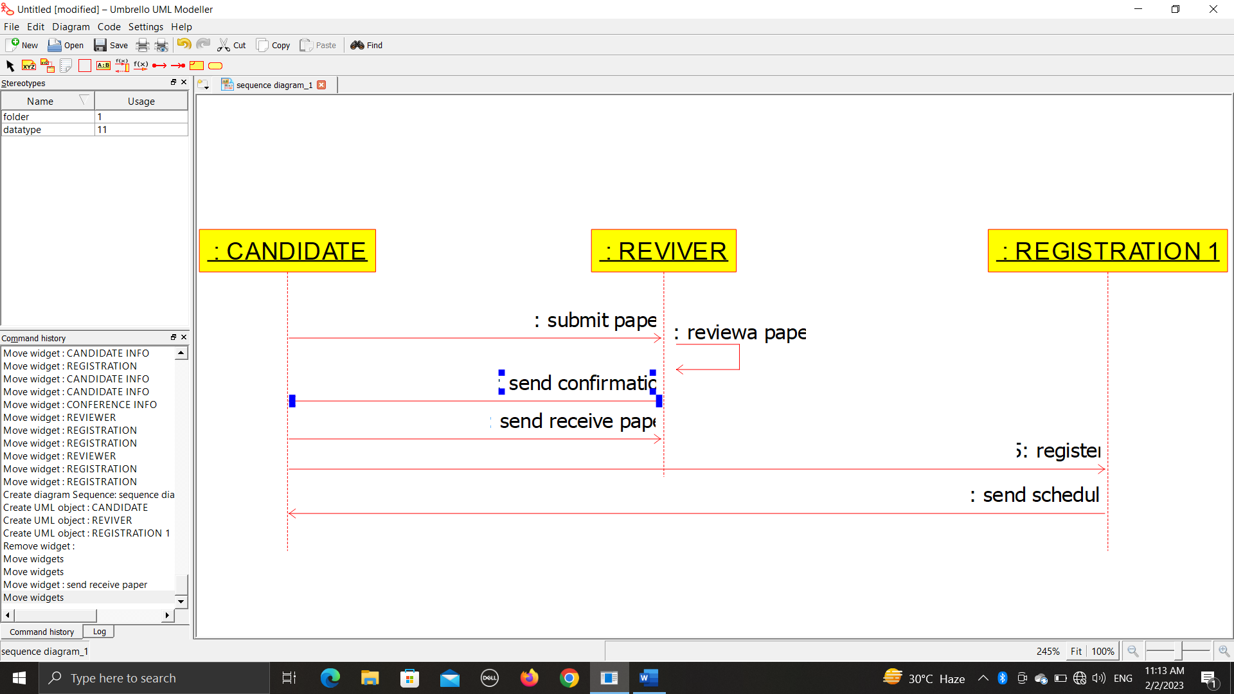

*Deployment diagram:*

